***Assignment of ICS:***

**Name: Sharjeel Badar Sheikh.**

**Roll Number: 60**

**Seat Number: EB 20102120**

***Source Code:***

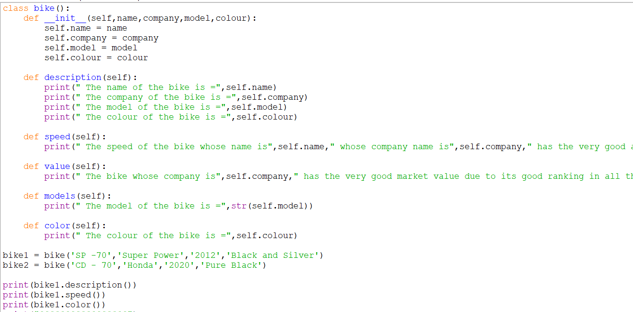

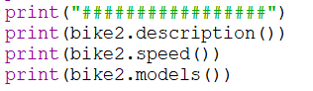

**Output:**

